**Project Design Phase-I**

**Proposed Solution Template**

|  |  |
| --- | --- |
| Date | 29 September 2022 |
| Team ID | PNT2022TMID40163 |
| Project Name | Project – Car Resale Value Prediction |
| Maximum Marks | 2 Marks |

**Proposed Solution Template:**

Project team shall fill the following information in proposed solution template.

|  |  |  |
| --- | --- | --- |
| **S. No.** | **Parameter** | **Description** |
|  | Problem Statement (Problem to be solved) | The main aim of this project is to predict the price of used cars using the various Machine Learning(ML) Models .This can enable the customers to make decisions based on different inputs or factors namely,  -Brand or Type of the car one prefers like Ford, Hyundai  -Model of the car namely Ford, Figo, Hyundai Creta  -Location like Delhi, Chennai, Mumbai  -Year of manufacturing like 2020,2021  -Type of fuel namely Petrol, Diesel  -Price range or budget  -Type of transmission which the customer prefers like Automatic or manual  -Mileage  To name a few characteristics features required by the customer .The Project car resale price prediction deals with providing the solution to these problems. Though this project, we will get to know which of the factors are significant and tell us how they us how they affect the Car’s worth in the market. |
|  | Idea / Solution description | -A model can be developed to predict and assign that price to the vehicle.  -To effectively determine the worthiness of used car by studying variety of features. |
|  | Novelty / Uniqueness | -Create new features from existing features.  -check the accuracy  -Data visualization  -Check the accuracy |
|  | Social Impact / Customer Satisfaction | To be able to predict used cars market value can help both buyers and sellers.  USED CAR SELLERS: They are one of the biggest target group that can be interested in results of this study. If used car sellers better understand what makes a car desirable, what the important features are used for a used car, then they may consider this knowledge and offer a better service.  ONLINE PRECING SERVICES: There are websites that offers an estimate value of a car. They have a good prediction model. Therefore, the model developed in this study may help online web services that tells a used car’s market value  INDIVIDUAL :There are lots of individuals who are interested in the used car market at same points in their life because they wanted to sell their car or buy a used car. |
|  | Business Model (Revenue Model) | Figure:1.1 |
|  | Scalability of the Solution | Vehicle price prediction can be a challenging task due to the more number of attributes that should be considered for the actual prediction. The collection and pre processing of data is the major step for prediction. In this paper ,to normalize ,standardize and to clean the data. |

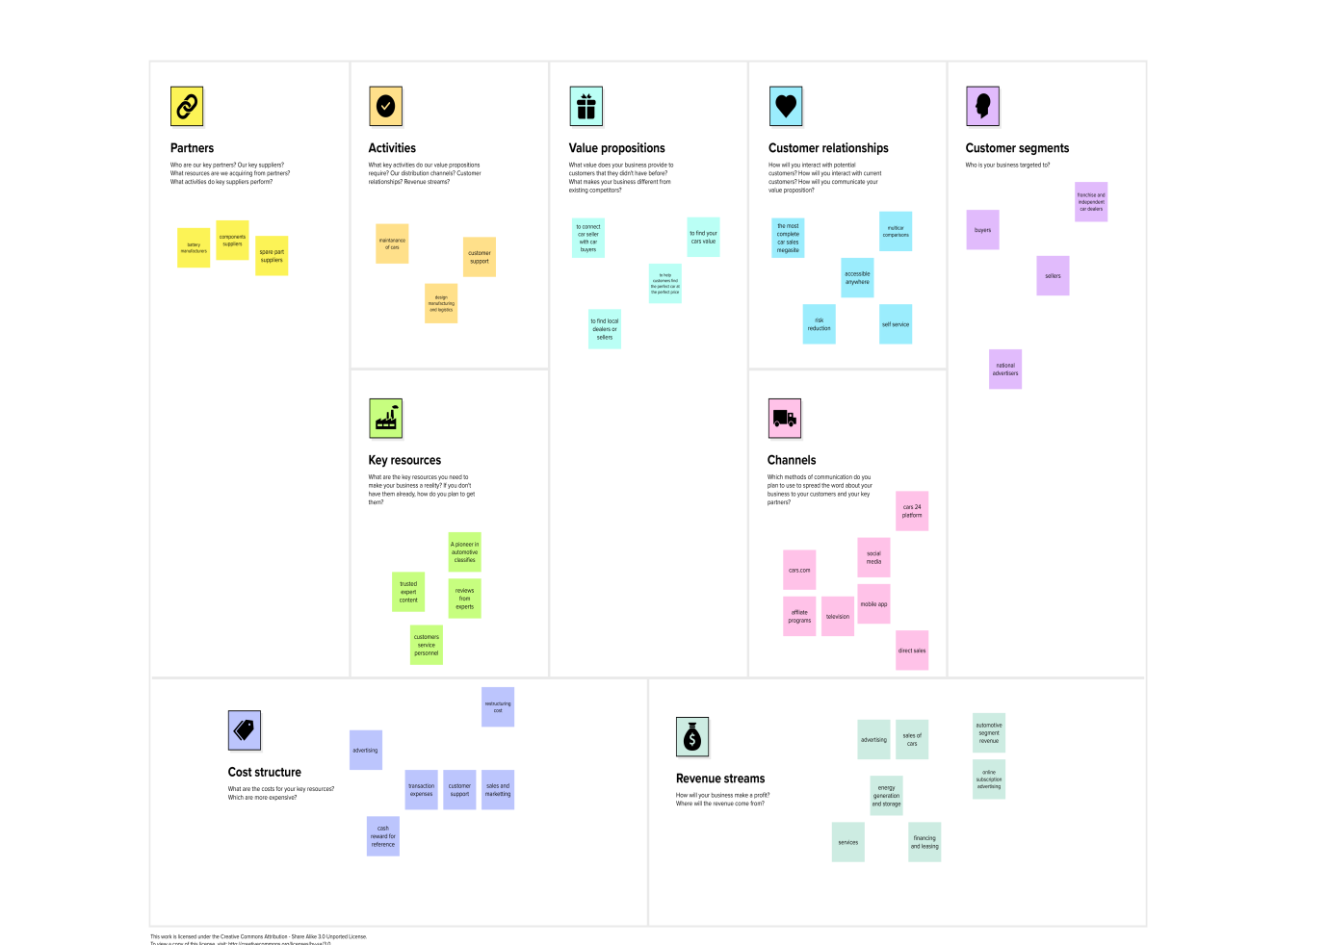

Fig 1.1